**Adam Parrish**

**How to Take Your Tricks**

**Adam Parrish is one of the top bridge teachers in the country. He writes a monthly column for the ACBL Bridge Bulletin, "Parrish the Thought." He is the author of *Bridge at the* *Cranmer Club* and *When to Draw Trump,* which was a finalist for the IBPA Bridge Book of the Year Award. His latest book is *When to* *Bid Notrump (And How to Play It*). He is active in promoting youth bridge; he is currently the youth coordinator for NYC and was the founding president of New England Youth Bridge. Adam is also a partner of the website, Bridge Winners.**

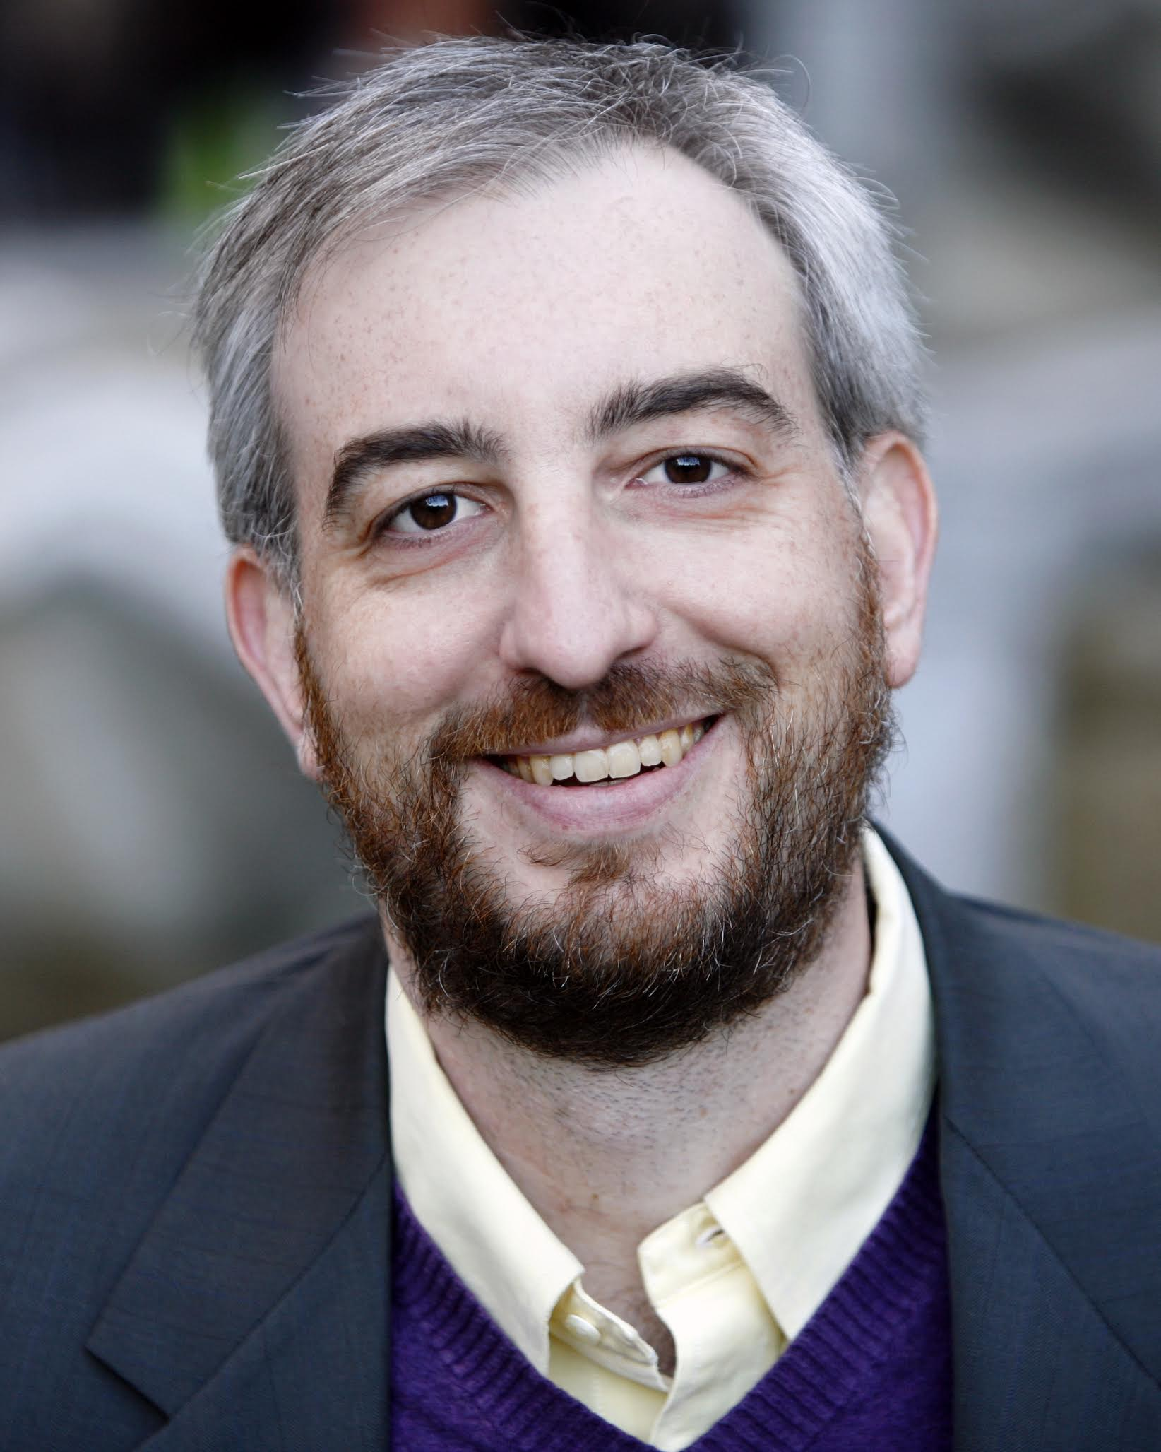

**Saturday, June 23 - 10:00 to 3:30**

**The Hellenic Center 54 Park Ave. Poughkeepsie, NY**

**$50 per person includes Workshop, Lunch,**

**Snacks, an 18-hand, Sanctioned Game**

**with a Chance to Partner with Adam!**

**Followed by a Discussion of Hands and a Question Session.**

Name__________________________________ Phone # _______________

Partner (optional) ________________________ Email ___________________

About how many points do you have? ____________

**QUESTIONS?** Cecilia Collopy: [ceciliacollopy@gmail.com](mailto:ceciliacollopy@gmail.com)  845-797-2294

Ilene Goldman: [jazzrgal@yahoo.com](mailto:jazzrgal@yahoo.com)  845-926-0207

Registration required by **June 15**. Pay by check only. Make check payable to DCBA.

**Send to: C. Collopy; PO Box 625; Millbrook, NY 12545**