Poughkeepsie, NY
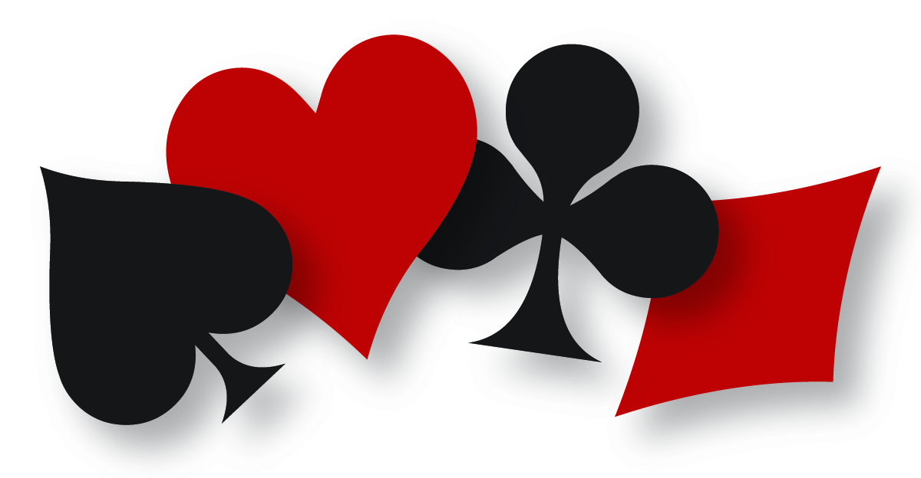
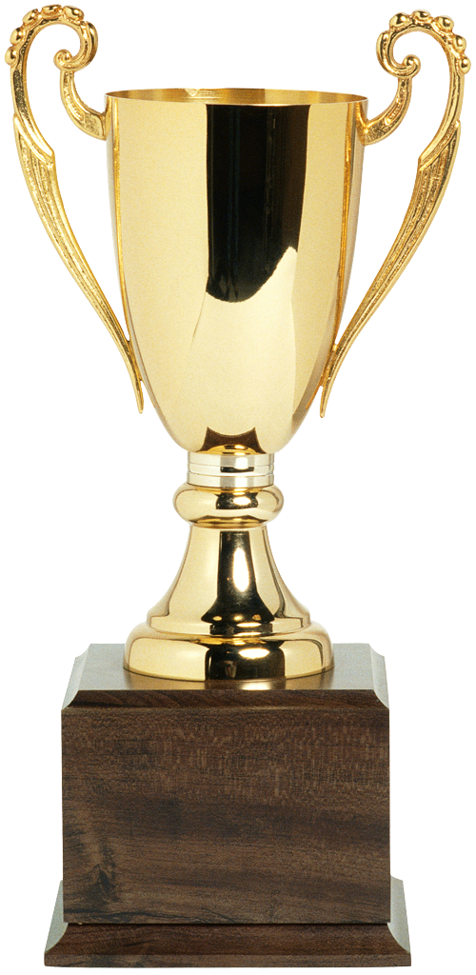 Unit 186
2018 Spring Sectional, May 4 -6

Dutchess County Bridge Association at the Hellenic Center,
54 Park Avenue, Poughkeepsie, NY - (845) 463-2919
SILVER POINTS!!
Tournament Co-Chairs:
Ceil Collopy-845-677-6018
ceciliacollopy@gmail.com
and
Bill Maine-845-473-1492
wmaine@aol.com
Partnership: Ann Mercer
845-463-2919 bridgecentermhv@gmail.com
Directions at www.dcbridge.com
Sanction #1805060
Pairs $13 ea. - Swiss $26 ea.
Single Session Swiss $15 ea.
Add $3 per person for non-or unpaid ACBL members.
Friday, May 4
Stratified Pairs (1 session)…..1:00 pm
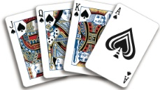
299er Pairs (1 session)…1:00 pm
Stratified Pairs (1 session)…..6:30 pm
Saturday, May 5
Stratified Pairs (1 session)…..10:00 am
299er Pairs (1 session)…10:00 am
Stratified Pairs (1 session)…..3:00 pm
299er Pairs (1 session)…3:00 pm
Sunday, May 6 (Lunch Included)
Bagels & Donuts at 10:15 am
Stratified Swiss Teams (by average)…..11:00 am (w/ lunch break)
299er Single Session Swiss ($15 ea. - 4 rounds)
Stratification A—1500 plus; B—750-1500; C—0-750 by average
DCBA Members: Prizes for Highest Total Points A,B,C & 299ers
Lunch included on Sunday; No fragrances, please!

